LIFE ON CAMPUS HANDBOOK
for Exchange Students


WELCOME
TO RENMIN UNIVERSITY OF CHINA
SCHOOL OF INTERNATIONAL STUDIES
We are glad to have you as one of our students and we hope that your experience will be exciting and rewarding.
The life on campus handbook for international students is designed to help you during your studies in Renmin University. It contains important information which you may need to refer to during your stay.
School of International Studies
Renmin University of China

Contents
1 BEFORE YOU ARRIVE 1
1.1 Apply for Visa 1
1.2 Book Accommodation 1
1.3 How to get to Renmin University of China 3
2 REGISTRATION 5
2.1 Registration for New Students 5
2.2 Semester Registration for Already Enrolled Students 6
3 VISA AND RESIDENCE PERMIT 7
3.1 X2 Visa 7
3.2 X1 Visa 7
3.3 Residence Permit 7
3.4 Internship Visa 9
3.5 Loss of Passport 10
3.6 Renewal / Replacement of Passport 11
4 LIFE ON CAMPUS 12
4.1 Healthcare 12
4.2 Dining 13
4.3 Internet Access 13
4.4 RUC Email Address 14
4.5 Phone Number 14
4.6 Student Card and E-Card 15
4.7 Mailing Services 15
4.8 Banking 16
4.9 Sports Facilities 16
4.10 Library 17
4.11 Shopping 21
4.12 Transportation 21
4.13 Lost and Found 22
4.14 Emergency and Other Useful Phone Numbers 22
4.15 Useful Links 22

BEFORE YOU ARRIVE

Apply for Visa
Foreigners coming to China for study shall apply for a study-purpose visa at the Chinese Embassy/Consulate in their country of nationality or country of residence.
There are two types of visas for study purposes: X1 type visas are usually issued to the students planning to study for over 180 days; X2 type visas are usually issued to the students planning to study for less than 180 days.
The International Students Office (ISO) of Renmin University will issue all the required documents including the Admission Notice and the Visa Application Form for Study in China (JW 202/201): they are usually sent by Mid-July. In order to apply for your visa, you will be required to present the above-mentioned documents and your passport to Chinese Embassy and Consulates.
Your passport must have a validity of at least 6 months from the date of the first entry in China. The registration day is usually in early-September, so your passport must be valid for at least six months starting from approximately September 10th. If your passport expiration date is earlier than that, please renew your passport in advance and send the new passport number as early as possible so that the ISO will have enough time to issue your visa application documents.
The passport number you will use to register must be the same as the one you used to apply for visa.
The list and contacts of Chinese diplomatic missions overseas can be checked on the website of Ministry of Foreign Affairs of China (http://www.fmprc.gov.cn/mfa_eng/wjb_663304/zwjg_665342/)

Book Accommodation
You will receive your room application form together with your admission documents. In order to apply for accommodation on campus please follow the instructions on the form.
The number of on-campus apartment rooms is limited and cannot meet the demands of all students who want to live on campus. Therefore, international students who intend to live on-campus are advised to book their room as soon as they receive the admission package.

On-Campus Accommodation
The Renmin University of China provides two types of dormitory rooms to the international students: single room (private bedroom and bathroom), RMB 80-100/day; double room (two beds in one room, shared bathroom on each floor), RMB 31-40/day/person. Included in each room are bedclothes, air-conditioner, telephone, Internet access, and furniture. Pictures of the dorms can be found here http://iso.ruc.edu.cn/English/more.php?cid=128

Off-Campus Accommodation
If you do not successfully book a room in the on-campus apartments, you need to arrange off-campus accommodation in advance. Thanks to the convenient location of Renmin University, many students decide to live off-campus. Remember foreigners living off-campus are required to register their accommodation to the police station within 24 hours. We are sorry that currently, the university is not able to officially recommend off-campus housing information and housing agencies for your off-campus accommodation.According to the experiences of our international students, many of them prefer to live in apartments near the campus or in the popular students’ area Wudaokou(五道口)where many foreigners live. Some students choose to live far from the campus because the rent might be much lower. The following links recommended by Renmin University international students may help you search online for appropriate off-campus apartments:
http://www.thebeijinger.com/classifieds/housing
http://bj.lianjia.com/zufang
http://ziroom.com
http://wellcee.com
Be aware of internet scams when looking for an apartment, you may need to ask some help from your Chinese Buddy or friends in Beijing. Please be careful when signing the contract or lease, since there may be hidden clauses. Note that you can require the landlord to provide a contract in English. Do not hesitate to ask the program staff for help.
Here is a list of the hotels surrounding RUC:
Beijing Yanshan Hotel, No.38A Zhongguancun Street, Hai Dian, 100086 Beijing, China
Beijing Friendship Hotel, No.1, South Zhongguancun Street, Hai Dian, 100873, Beijing, China
Beijing Millennium Youth Hotel, No.63 Shuangyu tree north road, Hai Dian, 100086, Beijing, China
Dadi Garden Hotel, No.35 Haidian Street, Haidian District, Beijing
Yongzheng Business Hotel 010-82611166 Suzhou Street No.72
For more hotels, pictures and prices you can check:http://www.booking.com/landmark/cn/renmin-university-of-china.html

How to get to Renmin University of China
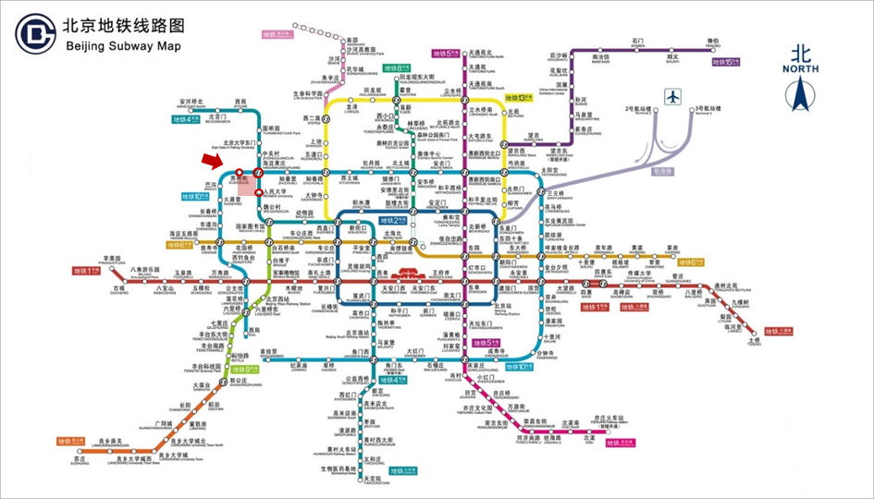
If you come to Beijing by plane, you can take the subway to the Renmin University of China. First, take the Airport Express from the airport station to Sanyuanqiao Station(三元桥), and then transfer to Line 10, transfer again at Haidianhuanzhuang(海淀黄庄) and take line 4, get off at Renmin University subway station (人民大学). Take exit A1 out of the subway and walk straight (direction north) for 1ess than5 minutes, and then you will see the East Gate of RUC on your left. You can also choose to take a taxi to RUC, and it will cost about 100RMB.
If you come to Beijing by train and arrive at the Beijing Station, you can take Line 2 to Xizhimen Station (西直门) and then change to Line 4 to Renmin University subway station (人民大学). Take the Exit A1 out of the subway and walk straight (direction north) for less than5 minutes, and then you will see the East Gate of RUC on your left. If you get to RUC by taxi, you may pay about 55RMB.
If you start from Beijing West Station, you should take Line 9 to National Library Station (国家图书馆) and transfer to Line 4 to Renmin University subway station (人民大学). Take the Exit A1 of the subway and walk straight (direction north) for 1ess than 5 minutes, and then you will see the East Gate of RUC on your left. The taxi will cost nearly 30RMB. You can also choose NO.374 Bus from Beijing West Station right to RUC.
If you go to RUC from Beijing South Station, take Line 4 to Renmin University subway station (人民大学). Take the Exit A1 out of the subway and walk straight (direction north) for 1ess than5 minutes, and then you will see the East Gate of RUC on your left. If you take a taxi, 45RMB or so may be the right price.
Instead of public transportation, you can choose to reach the university by taxi. Whenever you take a taxi make sure it is an official one, they are easily recognizable since they are yellow and green/blue and they have a license with the picture of the taxi driver + cab number + driver’s name in a plate in front of the passenger seat.
If you don’t speak Chinese, this is the address you can show the taxi driver:
中国人民大学东门 ( 59号中关村大街)


REGISTRATION
All international students need to register during the designated period each semester. The registration period usually starts during the first week of each semester. If you cannot register before the due day of registration, you need to get approval for your absence in advance. If you cannot complete the registration within one month from the due day of registration you will be automatically dismissed from RUC. Please contact our staff in advance if you cannot come on time for the registration day.

Registration for New Students

University Registration
The time and place of your registration will be written on your admission notice.
In order to register you must bring:
Admission letter
Visa application form for study in china (JW202/SW201, except for students with F visa or residence permit)
If available, the original documents of the physical examination record. Students who did not take the medical examination in their own country will have to do it when they arrive in Beijing. The ISO will organize a bus for international students to go to the medical examination center.
Passport
Five passport photos
The registration procedure is as follows:
Present your admission letter and obtain the registration form
Submit your medical insurance certificate or purchase the insurance (scholarship students do not need to purchase their insurance)
Non-scholarship students should pay their tuition. Scholarship students/exchange students sign in
Check your visa status with the staff
Obtain the letter of admission for your department
Register at your department (in Mindge International building, room 816B)

School of International Studies Registration
After you finish the University orientation, you will have to come to register to the CCSP office:
School of Int’l Studies, Mingde Int’l Building 816B,
中国人民大学国际关系学院,明德国际楼816B室
The time of your SIS registration will be provided during the university registration.

Semester Registration for Already Enrolled Students
At the beginning of each semester, already enrolled students need to register at their designated school and activate their student card in one of the machines usually located in the canteens, teaching buildings, and dorms (you simply need to insert your student card in one of the machines in the canteens and wait until the message 成功 appears). You will also need to leave your student booklet in the School office (room 816B, Mingde International Building). The registration period usually starts during the first week of each semester.


VISA AND RESIDENCE PERMIT
Visas and residence permit are among the most important documents that enable your legitimate entry and stay in China. International students who will study in China can apply to two different kinds of visa.

X2 Visa
X2 type visas are usually issued to the students planning to study for less than 180 days. If you are holding an X2 visa: the number of entries permitted and the duration of each stay (by days after each entry) are indicated on the visa. You shall remember the expiration date clearly, and register at the designated date on your Admission Notice.Please be noted that traveling from Hong Kong S.A.R, Macau S.A.R, and China Taiwan to mainland China counts as one entry.

X1 Visa
X1 type visas are usually issued to the students planning to study for over 180 days. If you are holding an X1 visa: you must register at the university and apply for a residence permit within 30 days after your entry into China, otherwise illegal stay is constituted. Usually, there is only one entry permitted on your visa. Since early registration is not entertained and it usually takes 3-5 days for the preparation of documents required for the residence permit application, it is suggested that you enter China no earlier than 1 week before the registration date designated on the Admission Notice.

Residence Permit
The X1 visa is valid only for 30 days after entry. The students holding X1 visas have to apply for residence permit at least 5 working days prior to the expiration date. The steps of the application are as follows:
- Register in the International Students Office and pay for tuition and medical insurance.
- If you have not taken the physical examination (including blood test), you shall take it at Beijing International Travel Healthcare Center (Haidian Branch). If you have a report from a doctor of your own country, you shall verify it at Beijing International Travel Healthcare Center. If the report is not qualified, you should re-take the physical examination at the Center.
- Get the Visa Application Permit from the International Students Office.
- Submit the documents to the authorized visa service agency in the lobby of the International Culture Exchange Center OR to the Beijing Municipal Public Security Bureau. The main branch of the bureau is located at No. 2 AndingmenDongdajie, Dongcheng District, Beijing. You can get there by subway line 2 and get off at Lama Temple station (雍和宫) exit B.
A new branch recently opened just opposite of Renmin University East Gate, they only receive by online appointment. If you wish to go there, please ask the ISO for assistance.

Application
If you choose the visa agency, you must bring the note from International Students Office, passport, residence registration card, ID picture (with white background) and other documents (admission notice, JW202 form, certificate of physical examination) to the agency. You will be given a receipt. Be aware that this receipt is not valid as a substitute of your passport and it will not be considered a valid document to travel within China. Please get your passport back by the designated date shown on the receipt. After you get back your passport/visa back, please get an updated residence registration card immediately.
If you choose to go to the Exit and Entry Bureau on your own, you must bring the visa application form (with the stamp from ISO), passport, residence registration card, ID picture (with white background) and other documents (admission notice, JW202 form, certificate of physical examination) to the Bureau. You will be given a yellow receipt with your picture on it. This receipt can be used to travel within China but train or long-haul buses. It may also be presented to register at hotels and hostels. Please get your passport back by the designated date shown on the yellow receipt. After you get back your passport/visa back, please get an updated residence registration card immediately.

Health Certificate
In order to obtain a residence permit, international students need to either take or verify their medical report at the Beijing International Travel Healthcare Center. The International Students Office organizes a free bus trip to the Center at the beginning of each semester.
If you cannot join the trip organized by the ISO you can reach the center taking the bus number 365 from outside of the east gate and get off at 西北旺镇政府站. It is a short walk from there to the medical center. We strongly suggest that you go to the Healthcare Center with the ISO staff, so that they can help you with translation in case of need.

Residence Registration Card
If you hold a residence permit, you will also need a residence registration card.
For the students living on campus, please get the Residence Registration Card at the reception desk of the International Cultural Exchange Center.
For the students living off-campus:
- Hotel: please get the Residence Registration Card at the reception desk of the hotel.
- Apartment or Local Residence: please get the Residence Registration Card at the local police station.
After you got the new passport, moved to a new house, or got a new visa, you should immediately get a new Temporary Residence Registration Card.

Extension
When an international student with a residence permit needs to extend the duration of residence to continue his/her study, he/she needs to file an application of residence permit extension, at least 30 days prior to the expiration of your residence permit. The documents required for the residence permit extension are as follows:
The valid passport;
The Visa Application Permit issued by the International Students Office;
One passport-size photo (2 inches, facing the front, without hat, white background);
A photocopy of the Registration Form of Temporary Residence.

Internship Visa
According to the regulations of the People’s Republic of China, students who wish to have a part-time job or partake in an internship should add the internship visa to their passport. In order to do so, you should hold a valid Residence Permit on your passport. Your internship can only be done in Beijing or Tianjin. The duration of the internship should be equal or less than the length of your study.
In order to apply for the internship visa, you should prepare the following documents:
- Passport
- Residence registration form
- “Adding Internship to Residence Permit Application Form” (This should be approved by the school with signature and stamp before applying to ISO, and it can be download at http://iso.ruc.edu.cn/English/more.php?cid=276)
- Company Information Form (template can be downloaded at http://iso.ruc.edu.cn/English/more.php?cid=276)
- ID Photo（3.5X5.3cm full-face recent photo with white background）
- Internship Agreement from the Employer (template can be downloaded at http://iso.ruc.edu.cn/English/more.php?cid=276, and the form should be typed on a computer)
- Business License of the Employer (if the employer is the Embassies and Consulates, there is no need to provide the license.)
For more information, please contact the ISO.

Loss of Passport
When an international student finds out that his/her passport is lost, he/she must go through the following procedures:
- Immediately report to the local police station and obtain a receipt of case report;
- Contact the International Students Office as soon as possible to get a letter of student status and passport loss statement;
- Bring the two documents above and go to the Department of Exit and Entry Administration, Beijing Municipal Public Security Bureau (the Visa Center) to get the Certificate of Passport Loss;
- Apply for a new passport with the Certificate of Passport Loss in the Embassy of his/her home country in China;
- Within 24 hours from the new passport is issued, bring the Certificate of Passport Loss and new passport and go to the local police station or the international student apartment where he/she is accommodated to renew the Registration Form of Temporary Residence; within 10 days, apply for a new visa or residence permit via the International Students Office, following the procedures described above;
- Within 24 hours from the new visa or residence permit is issued, go to the local police station or the international student apartment where he/she is accommodated to renew the Registration Form of Temporary Residence.
It is a violation of law to stay with a new passport but failing to apply for a new visa/residence permit within 10 days from issuance of passport.

Renewal/Replacement of Passport
If an international student plans to renew or replace the passport in the Embassy of his/her home country in China, he/she shall apply to the Embassy 2 to 3 months prior to the expiration of the validity period of the residence permit. When the new passport is issued, the student shall apply for the alteration of the residence permit within 10 days after the issuance of the new passport.
If a new passport is issued to an international student in his/her own country, and he/she enters into China with the new passport and the still valid residence permit on the old passport, he/she shall go through the formalities for the alteration of the residence permit within 10 days after the entry.
The documents required for the alteration of residence permit are as follows:
The new passport and the old passport with the valid residence permit;
The Visa Application Permit issued by the International Students Office
One passport-size photo (facing the front, without hat, white background);
A photocopy of the Registration Form of Temporary Residence.
Please remember to update your accommodation registration and obtain a new Registration Form of Temporary Residence in the international student apartments, hotel, or local police station within 24 hours after getting your new residence permit.It is a violation of law to stay with a new passport but failing to alter the residence permit within 10 days from the issuance of a new passport in China.


LIFE ON CAMPUS

Healthcare

Medical Insurance
The Ministry of Education requires every eligible international student to be covered by a comprehensive health insurance plan, including at least accidental injuries, hospitalization, and high-quota medical care. For International students receiving Chinese Government Scholarships and Confucius Institute Scholarships, the health insurance plan will be paid by the Chinese Government. Self-financed international students are strongly recommended to buy a comprehensive insurance package provided by the Ping An Annuity Insurance Company when you register at the ISO. Generally, the insurance premium for international students studying in China is 300 yuan/ semester.
For details on the insurance coverage, please contact the Ping An Annuity Insurance Company at +86-10-5973-1677 or +86-10-5973-1688, or visit http://www.lxbx.net.
International students without appropriate insurance will not be allowed to register.

Hospitals
Comprehensive health services are provided at the campus hospital. If you need more specific/advanced medical treatments or in case of emergency, we strongly suggest you go to No.3 Hospital of Peking University (BEIYISANYUAN 北医三院) or Beijing Haidian Hospital, which are close to the RUC campus.
Hospital surrounding RUC:
Hospital Name | Address | Telephone
The Renmin University of China Campus Hospital | On-campus | (010) 6251-1470
No.3 Hospital of Peking University | #49 North Garden Road, Haidian District, Beijing | (010) 8226-6699
Beijing Haidian Hospital | #29 Zhongguancun Street, Haidian, Beijing | (010) 8261-9999

Mental Health Consultation
The Renmin University of China provides mental health consultation and peer counseling to students. Students can make an appointment through the online system. The office hour is from Monday to Friday, 09:00-11:00, and 14:00-17:00. The late office hours are 17:00-19:00, every Tuesday, Wednesday, and Friday. The consultation will last for 45 minutes per session.

Dining
RUC serves a variety of food at convenient locations throughout campus. The East Canteen, Central Canteen, West Canteen, North Canteen, and South Canteen (Jitian Restaurant) are the major canteens where Chinese food is served and you are required to pay with the student card (Wechat pay and Alipay are available in some canteens).
In addition, international students have other dining choices on campus, for example:
- Circle Caféis located between the International Culture Exchange Center and International Students Dorm 1; it is open from 9 am and it serves brunch until 11:30 am, it also serves many western dishes such as pasta, burgers, tacos, nachos, salads and snacks. It also serves a wide variety of coffee, tea, juices and deserts. In the evening, it is a popular spot for drinks, movie nights and live music.
- Laneway Caféis located in the International Culture Exchange Building (Gaoli) and has a varied menu that includes burgers and steaks.
Other cafes include Water Stone Café, Maan Café. Two restaurants offer Halal food, one is located next to the tennis courts, the other one is on the ground floor of the north canteen.

Internet Access
The Internet serves as a significant medium through which you obtain knowledge inside and outside the classroom. The Internet will be automatically connected. However, you must log in to have a connection. The username is your student ID number and the password is usually the last six digits of your passport number.
If you encounter a problem regarding the campus Internet, please visit http://nic.ruc.edu.cn or call (010) 6251-5292 (Chinese language only). You can also ask for technical support from the staff at the IT Service Center (located near the library).
Wired network: if your computer is connected to RUC net port, then you just need to open your web browser. And there will be a website where you can log in your net account. After logging in, you can use the Internet.
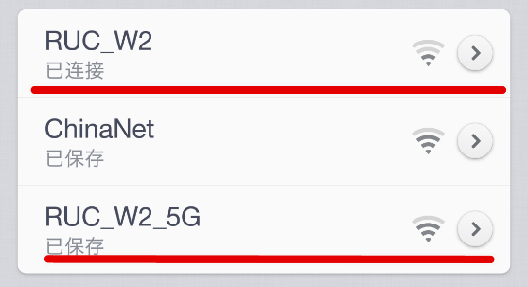
Wireless network: first, connect to the Wi-Fi of RUC. The Wi-Fi connections are named RUC_W1/2/3.
Then you open your web browser, and there will be the same website where you can log in to your net account. After logging in, you can use the Internet.

RUC Email Address
As a Renmin University student, you are entitled to a ruc.edu.cn email address. In order to set it up, please follow the following steps
1. Go to http://mail.ruc.edu.cn/
2. Click on 注册
3. Login with username and password you use for campus Wi-Fi
4. Follow the instructions

Phone Number
Students can buy a SIM card during registration and/or in the lobby of the Cultural Exchange Center during the first few days of registration.
If you miss this chance, you can go to one of the phone companies on your own.
There are three main Chinese phone carrier companies where international students can purchase a SIM card:
China Unicom: across from RUC West Gate
China Mobile: next to the east district canteen
China Telecom: west side of century gymnasium

Student booklet and one-Card

Student Card
International students will get the student booklet in one to two weeks after officially registering with university.Undergraduate and graduate students’ student booklets will be given by the Office of Student Affairs. Students should register with the university in their related department/school at the beginning of each semester. In case the booklet was lost, students can go to the Office of Student Affairs to get a new one. The Office is located in room 609, North Canteen.The student booklet is an important identification of the students. The booklet cannot be forged or damaged or lent to others. If you have misplaced your student ID, please get a new one as soon as possible.

ONE-Card
The one-card is an important identification. You can use your Onecard to eat in canteens, use the library, register, enter teaching buildings, pay for the internet, etc. Please keep the card safely. If you have lost your one-card, please get a new one at the IT Service Center.

Mailing Services

Post Office
The post office is located at the northeast corner of RUC. It provides the RUC community with an efficient and economical mail system that ensures quick and accurate delivery for both incoming and outgoing mail and packages. The post office is open between the hours of 9:00-15:00. If you have any question about the services, you can contact the post office staff at (010) 6251-0603.

Receiving Mail and Express Mail Services
Letters and small packages received via the post office will be delivered to the respective RUC international students buildings. For larger parcels, registered mail, and other special services such as money orders, students will be informed upon the item’s arrival and may have to obtain their parcel notice from the front desk, before picking up the item directly from the post office.
In addition to the express mail services offered by the post office, there are several express mail vendors located at the north gate of the campus, near the Zhi Xing (知行) student dormitory. These express mail services primarily service online shopping deliveries and returns, but they also provide express shipping services within China. To pick up a package, students simply need present the unique code that is sent to them via text when their package arrives. To ship a package, students should provide the item, the address of the sender and receiver, as well as their cell phone number.

Banking
Opening a bank account is one of the most important steps in your settling in as a university student in China. As your Chinese bank account number will be required for several steps in the registration process and for general use in China— to pay tuition, administer your scholarship, to link your student card to your bank card, making purchases, etc.—you are strongly recommended to open a bank account as soon as possible. Remember to take your passport and other valid documents/information, such as your admission notice, temporary residence form, a valid Chinese phone number, visa and cash.
There are several banks on campus and close to RUC. In the Culture Plaza (the tall building located outside of the east gate), there is a Bank of China. There are also several other banks outside of the east gate, including China Merchants Bank and China Citic Bank. You will also find more banks in the west gate area, including an Industrial and Commercial Bank of China (ICBC) located inside of the Huixian building; and China Construction Bank, China Agricultural Bank, and another Bank of China outside of the west gate.

Sports Facilities
The campus offers many sports facilities:
Sport facilities in Century Gymnasium | Room | Opening time | Preferential Price (With Student Card)
Gym | South 301-303 | 9:00-21:00 | Single entrance: 50RMB  12 entrances card: 400RMB  Monthly card: 300RMB
Tennis court (indoor) | B214 | 8:00-21:00 | Mon-Fri:  8:00-17:00 80RMB/hour  17:00-21:00 120RMB/hour  Sat-Sun: 120RMB/hour
Basketball court (indoor) | B208 | 8:00-21:30 | 450RMB/hour
Volleyball court (indoor) | B206 | 8:00-21:00 | 450RMB/hour
Badminton court (indoor) | Main Court | 8:00-21:30 | Mon-Fri:  8:00-17:00 20RMB/hour  17:00-21:00 35RMB/hour  Sat-Sun: 35RMB/hour
Table tennis court (indoor) | North 201 | 8:00-21:15 | Mon-Fri:  8:00-17:00 8RMB/hour  17:00-21:00 12RMB/hour  Sat-Sun: 12RMB/hour

Swimming Center | Opening Time | Price
Mon-Fri | 10:00-16:00  16:00-21:00 | 8RMB/2hours  10RMB/2hours
Sat-Sun | 10:00-14:00  14:00-21:00 | 8RMB/2hours  10RMB/2hours
Monthly card: 400 RMB

Football Court | Opening Time | Price | Light (at night)
Seven-man field | Mon-Fri 8:00-22:00 | 80RMB | 100rmb
Seven-man field | Sat-Sun 8:00-22:00 | 500RMB | 100rmb
Five-man field | Mon-Fri 8:00-22:00 | 60RMB | 50rmb
Five-man field | Sat-Sun 8:00-22:00 | 400RMB | 50rmb

Outdoor Tennis Court | Opening time | Price/hour | Light (at night)
Mon-Fri | 7:00-16:00 | 30RMB | 10rmb/hour
Mon-Fri | 16:00-22:00 | 40RMB | 10rmb/hour
Sat-Sun | 7:00-22:00 | 60RMB | 10rmb/hour

Track and field: open every day from 6:00 to 22:00 (free entrance)
West District basketball court: open every day from 8:00 to 22:00 (free entrance)
Outdoor tennis table court: open every day from 8:00 to 22:00 (free entrance)
Outdoor gym: open 24/7 (free entrance)
South district basketball court: open every day from 6:00 to 22:00 (free entrance)

Library
The student card allows RUC students free access to the library. For undergraduate students, up to 10 books can be borrowed at one time. For graduate students, the maximum number of books that can be borrowed at one time is 15. Students can hold one book for as long as 4 weeks. All books can be renewed only once for 4 weeks. New books can only be borrowed for 7 days and cannot be renewed. You can recognize new books by the red mark 新 on the side. Books in the reading rooms can only be read inside and not borrowed.
In order to use the online sources, you can use the Online Public Access Catalogue (OPAC).

How to Book a Seat in the Library
- Find this machine:
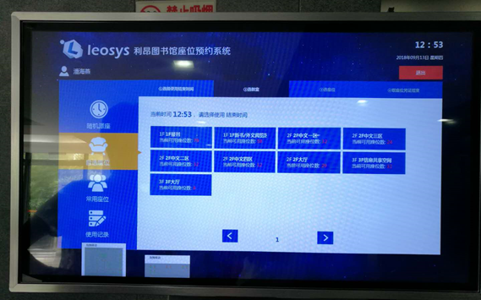
- Put your card in:
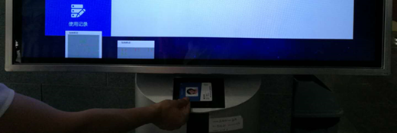
- Select the time you plan to leave the seat:
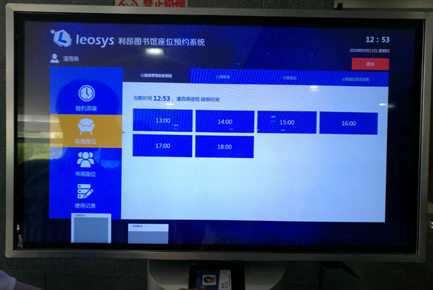
- Choose the room:
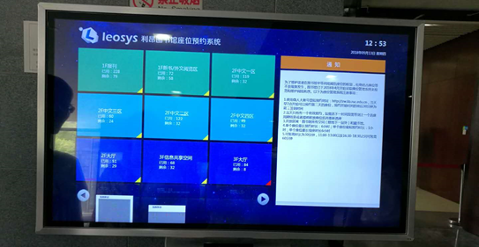
- Choose a seat:
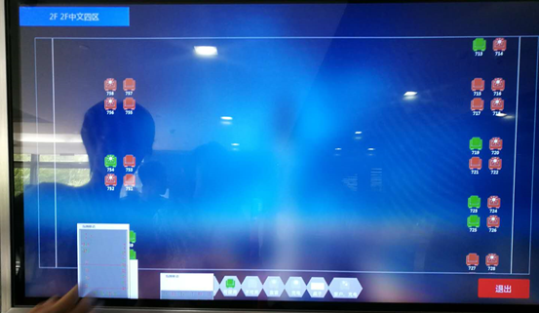
- Click on 确定:
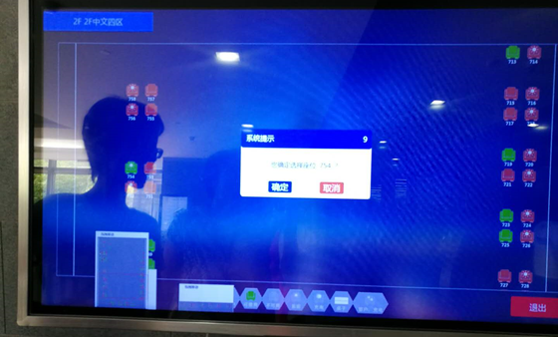
- A memo with selected seat and time will appear:
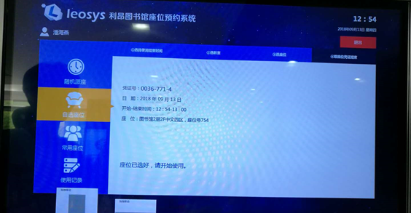

How to book a Study Room in the Library
- Go to http://kjyy.lib.ruc.edu.cn/ClientWeb/xcus/ic2/Default.aspx
- Choose the type of study room:
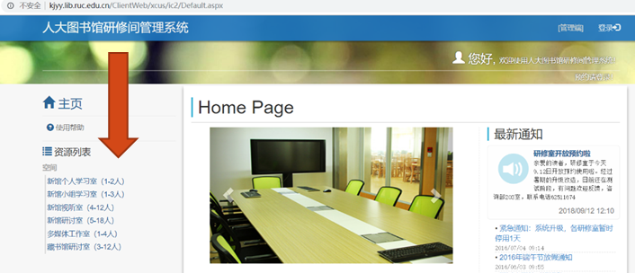
- Choose the room (please keep in mind that if a room is for 4-12 people, at least 4 people should swipe the card to enter, if the room is for 5-18 people, at least 5 people should swipe the card and so on...); choose the time (blue = busy; white = available)
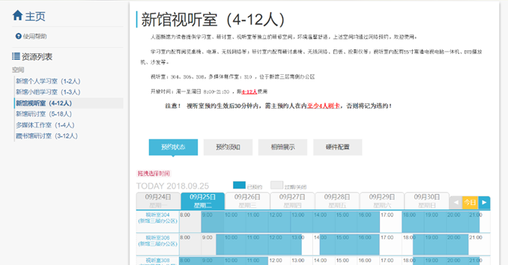
- Insert your student number and password (same credentials you use when logging on the campus Wi-fi)
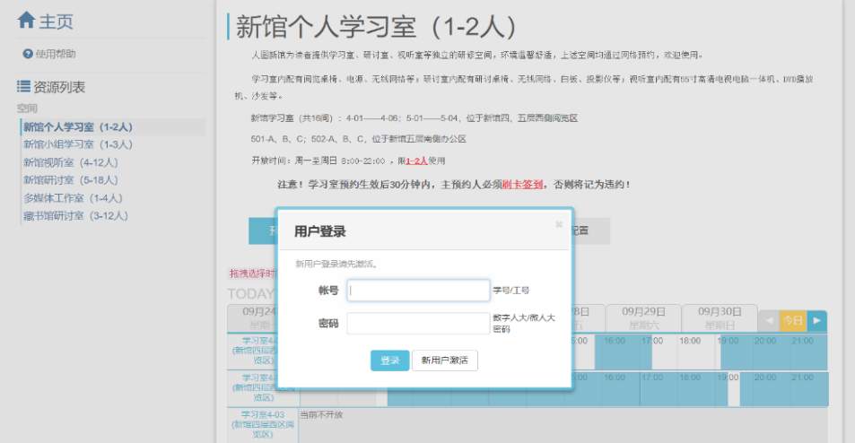

Shopping
Malls surrounding RUC:
The Gate City Mall, Zhongguancun South Road No.12 Haidian, Beijing China
EC Mall, A- No.1, Danling Street No. Haidian, Beijing China
Supermarkets surrounding RUC:
Carrefour, Zhongguancun St, 15号中关村广场
Chaoshifa, Side Road of N. 3rd Ring Road West (Renmin University Subway Exit B)

Transportation
Your transportation options around RUC are various. Regarding public transportation, RUC is within 5 minutes’ walking distance to many subway stations and bus stops.In terms of the Beijing subway, you can take Subway Line 4 at the Renmin University Station which is close to the East Gate of the RUC. Line 10 passes through HaidianHuangzhuang Station around the East Gate and the Suzhou Street Station close to the West Gate. For more Beijing subway information, please visit http://www.bjsubway.com.
It is also convenient to travel around Beijing by bus. A variety of bus lines pass through the Renmin University bus stop at the East Gate and the Suzhou Street bus stop close to the West Gate. For bus line query, please visit http://www.bjbus.com.
Also, the highly-developed transportation system both for arriving at and departing from Beijing facilitates your traveling. There are three airports in Beijing.
In addition to the airlines, approximately 200 railway services to and from Beijing in five railway stations in Beijing ensure your convenience of traveling.
A list of railway stations is as follows:
Railway Station | Address
Beijing Railway Station | A13 Maojiawan Hutong, Dongcheng District, Beijing
Beijing East Railway Station | 7 Baiziwan Road, Chaoyang District, Beijing
Beijing West Railway Station | 19 Guanglian Road, Fengtai District, Beijing
Beijing South Railway Station | 12 Yongdingmen Outer Street, Chongwen District, Beijing
Beijing North Railway Station | Side Road, Xizhimen North Road, Xicheng District, Beijing

Lost and Found
If you lost your personal items, such as cell phone, computer, etc., you can put up a poster on the following social media or call the on-campus security office. Below are some social media addresses:
- Ping’anRUC (Sino Weibo)
http://weibo.com/u/3225086454?topnav=1&topsug=1
- Lost and Found E-RUC
http://i.ruc.edu.cn/dcp/forward.action?path=/portal/portal&p=lostHomePage#pt%3DpublicLost%26ptc%3DpublicLost%26ptcType%3D0
- Pinzhi RUC
http://bu.ruc6.edu.cn
- Tiandi RUC
http://www.tdrd.org/nForum/#!board/LostAndFound

Emergency and Other Useful Phone Numbers
- On campus security: (010) 6251 5911
- Police station: 110
- First-aid (ambulance): 120 or 999
- Fire emergency:119
- Traffic accident reporting: 122
- Information enquiry (e.g. phone number): 114
- Beijing weather forecast: 121

Useful Links

- RUC Int’l Students Office website
http://iso.ruc.edu.cn/English/
- RUC English-language website
https://www.ruc.edu.cn/en
- RUC Chinese-language website
https://www.ruc.edu.cn/
- RUC library
http://www.lib.ruc.edu.cn/
- CCSP website
http://chinastudies.education/
- CCSP application website
https://account.chinastudies.education/
- Beijing Municipal Public Security Bureau
http://www.bjgaj.gov.cn/jjcrj/index.jsp
- Updated RUC academic calendar
https://www.ruc.edu.cn/calendar
- School of International Studies website
http://sis.ruc.edu.cn/
- Chinese Government Scholarship website
http://www.campuschina.org/

